
Company
Logotype

Cone Beam Computed Tomography- Report



Porur Dental X-rays & CBCT

Patient Name : Mr. Thirunavukarasu | Date of Report : 24.03.2024
Age/ Gender : 55 years/ Male | Region of Interest : CBCT Mandible
Referring doctor: Dr. Suchitra Mohan | Indication : Implant assessment
Clinical Notes: Nil
PATIENT INFORMATION

CBCT- Mandible provided
CBCT – IMAGE DETAILS

RADIOGRAPHIC INTERPRETATION

- Partially edentulous mandibular alveolar ridge (tooth present: 38)
- The mandibular alveolar ridge is present with normal trabecular pattern.

IMPLANT ASSESSMENT

 | 31 region | 32 region | 33 region | 34 region
Sub-Crestal (in mm) | 5.26 | 7.43 | 5.06 | 4.84
Mid- Crestal (in mm) | 6.87 | 9.45 | 8.22 | 8.01
Distance between alveolar ridge and the inferior border of mandible (in mm) | 21.9 | 21.75 | 22.81 | 22.7
 | 41 region | 42 region | 43 region | 44 region
Sub-Crestal (in mm) | 7.08 | 6.98 | 7.98 | 8
Mid- Crestal (in mm) | 8.1 | 8.32 | 10.46 | 10.71
Distance between alveolar ridge and the inferior border of mandible (in mm) | 19.83 | 20.02 | 20.2 | 20.3

 | 35 region | 36 region | 37 region
Sub-Crestal (in mm) | 7.52 | 6.07 | 6.47
Mid- Crestal (in mm) | 8.66 | 9.46 | 9.92
Distance between alveolar ridge and the inferior alveolar nerve canal (in mm) | 9.69 | 9.33 | 9.28
Distance between alveolar ridge and the inferior border of mandible (in mm) | 21.88 | 21.81 | 20.08

 | 45 region | 46 region | 47 region
Sub-Crestal (in mm) | 7.33 | 8.24 | 8.32
Mid- Crestal (in mm) | 10.71 | 10.79 | 11.47
Distance between alveolar ridge and the inferior alveolar nerve canal (in mm) | 9.61 | 8.47 | 8.1
Distance between alveolar ridge and the inferior border of mandible (in mm) | 20.3 | 18.47 | 19.22

RADIOGRAPHIC IMPRESSION

- Partially edentulous mandibular alveolar ridge.

Kindly correlate with clinical findings


IMAGES FOR REFERENCE

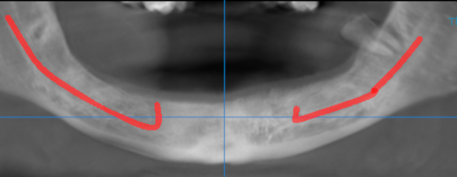

3-DIMENSIONAL VIEW

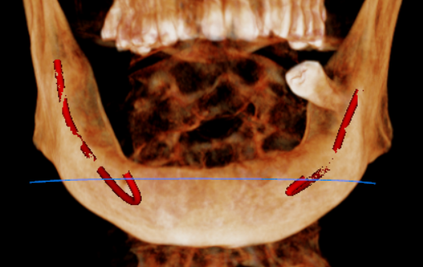

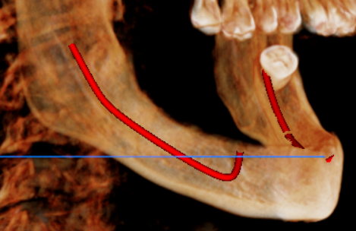
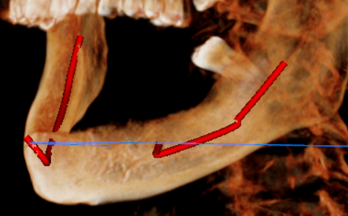

CROSS SECTIONAL VIEW

31 region | 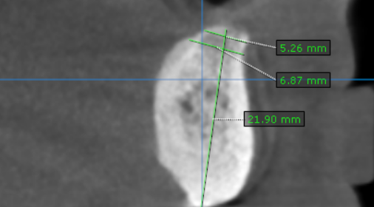
32 region | 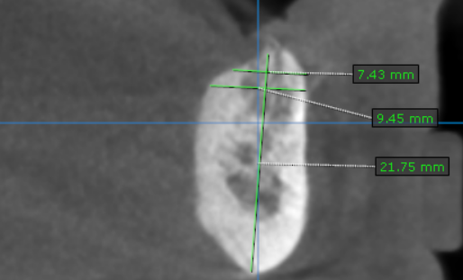
33 region | 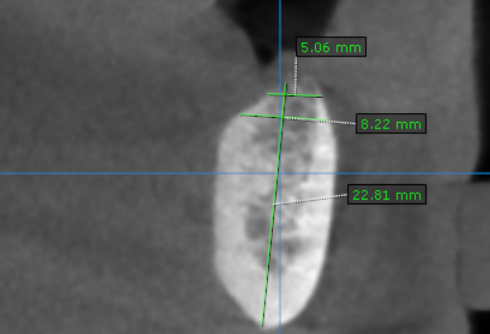
34 region | 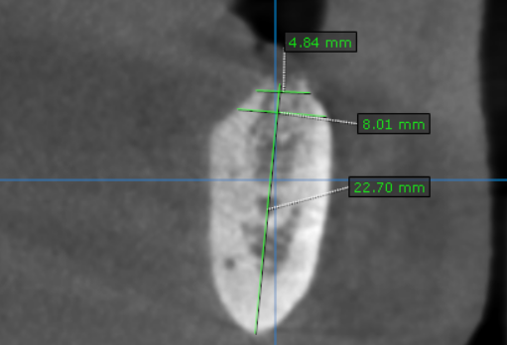
35 region | 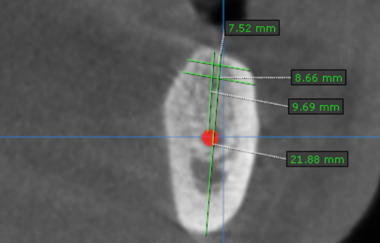
36 region | 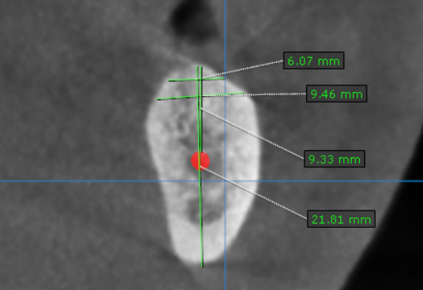
37 region | 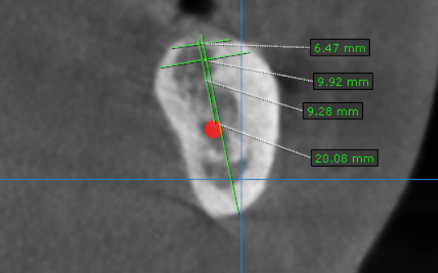
41 region | 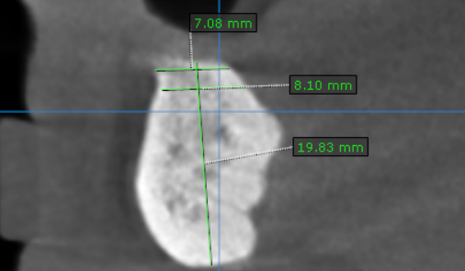
42 region | 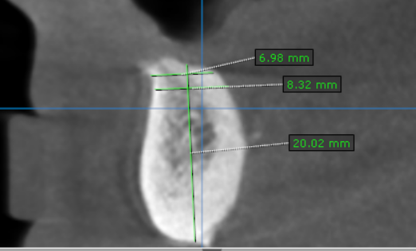
43 region | 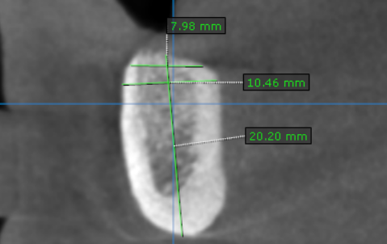
44 region | 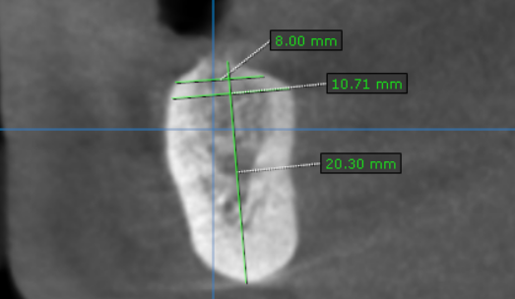
45 region | 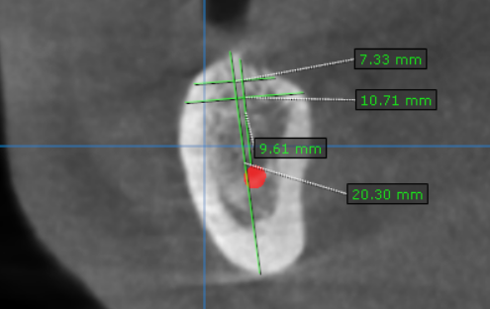
46 region | 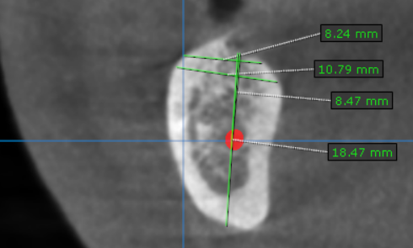
47 region | 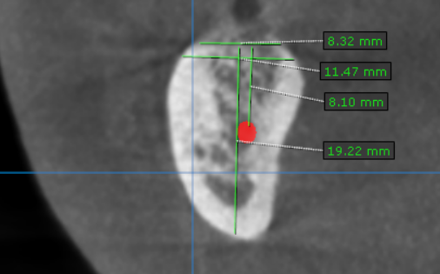

**** End of report ****

